Preparing your system for taking a test or exam with TextAid’s ExamMode

If you wish to take a test or exam, you can use exam accounts in TextAid. In addition to using exam accounts, the internal connection of laptops or Chromebooks should be restricted. This article deals with whitelisting and blacklisting of internet addresses (urls) so that students can only log in to their TextAid exam account.

Blacklisting and whitelisting

By blacklisting internet access, for example in a teacher's environment on your school network, Google Admin or by your school’s IT department, you ensure that students are denied access to all those online activities on the blacklist.

In order to safely use TextAid ExamMode, we recommend using the following settings:

Blacklist:
*
ws.readspeaker.com
www.readspeaker.com

blacklist exceptions (whitelist):
ws-exam.readspeaker.com
*.readspeaker.com

The effect is that everything is blocked at first (by means of the * / asterisk). The exception is the login page for the exam account, which can only be accessed through ws-exam.readspeaker.com. Furthermore, it is important to leave *.readspeaker.com open because after logging in, components need to be loaded in the background for displaying the test or exam document and for loading the various reading voices/audio playback. By blocking ws.readpseaker.com and www.readspeaker.com separately you prevent students from logging in anywhere other than the specific login page for exam accounts only.

Example in practice: Limiting access with the Google Admin Console
Note: This article is intended for schools using G-Suite, which manages browsers, Chromebooks and Google accounts.

Before you start: This article deals with whitelisting and blacklisting of urls so that students can only use the testing environment of TextAid. We assume in this article the use of the Administrator Console in G-Suite for managing Google accounts in chrome browsers or a device with Chrome OS. (Chromebook)

Extensive information on managing access to websites in Chrome can be found here: https://support.google.com/chrome/a/answer/7532419?hl=en

Do the following in the Google Administrator Console (via admin.google.com):

- Go to Devices > Chrome management. (Click on the link to go there directly)

- Click on User Settings.
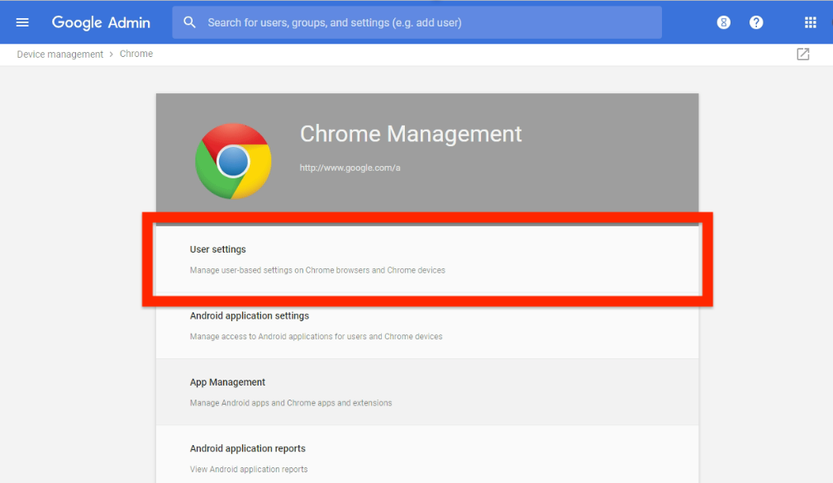

- On the left, select the organisational unit with the users or enrolled browsers for which you want to set the policy.

- Scroll down to the Startup section. Here you set the homepage. Make sure this is the url: https://ws-exam.readspeaker.com/a/wasp/app/8. This is the login for exam accounts.
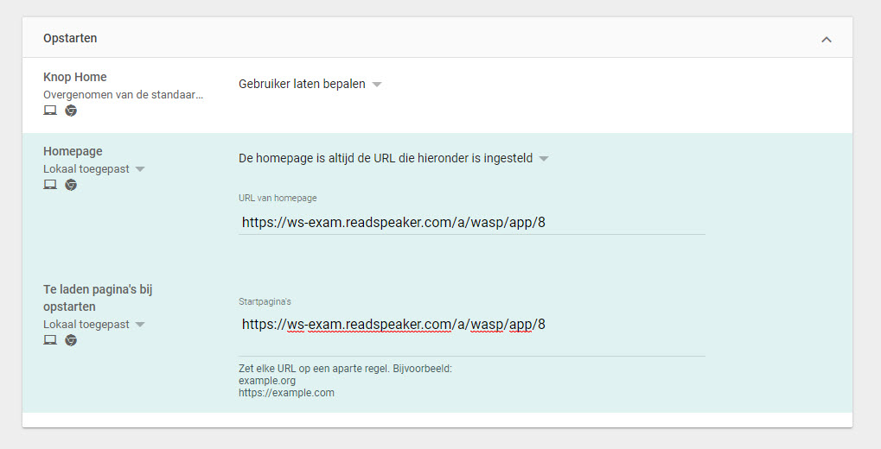

- Scroll further down to the section URL blocking. Enter the following data here.
Under URL-blacklist:
*
ws.readspeaker.com
www.readspeaker.com

Under URL blacklist exceptions:
ws-exam.readspeaker.com
readspeaker.com

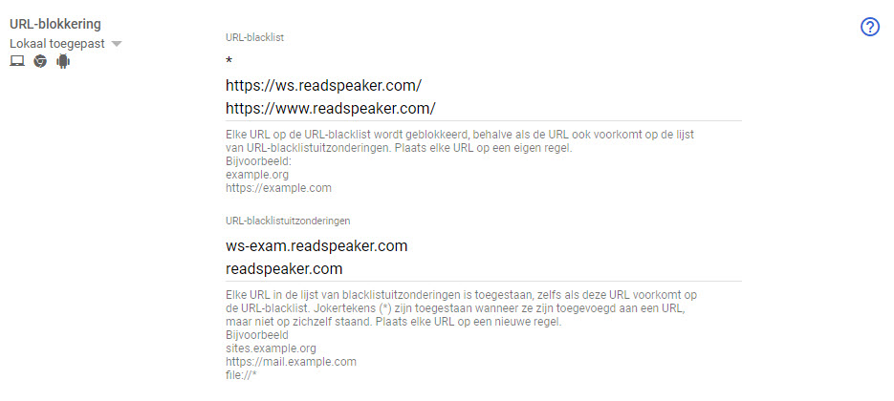

Save these settings. The users that you selected in step 3 can now only log in via the TextAid login. As soon as Chrome is started, they will see this login page.

readspeaker.com needs to be open because after the login, components need to be loaded in the background to display the key and load the different reading voices. Blocking ws.readpseaker.com and www.readspeaker.com separately prevents students from logging in anywhere other than the login page for test account.

